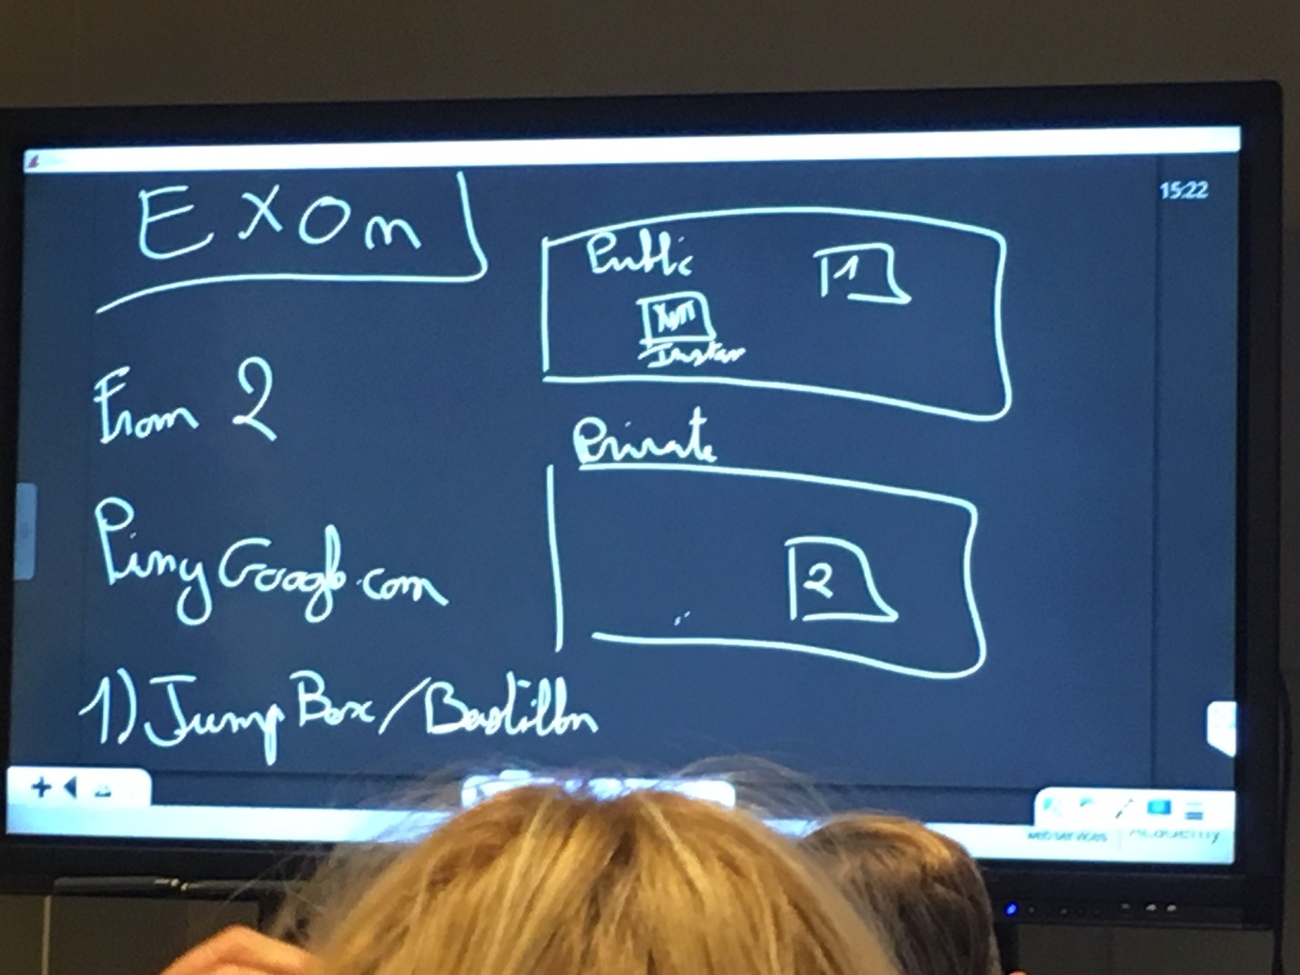

Create VPC « ExoN »

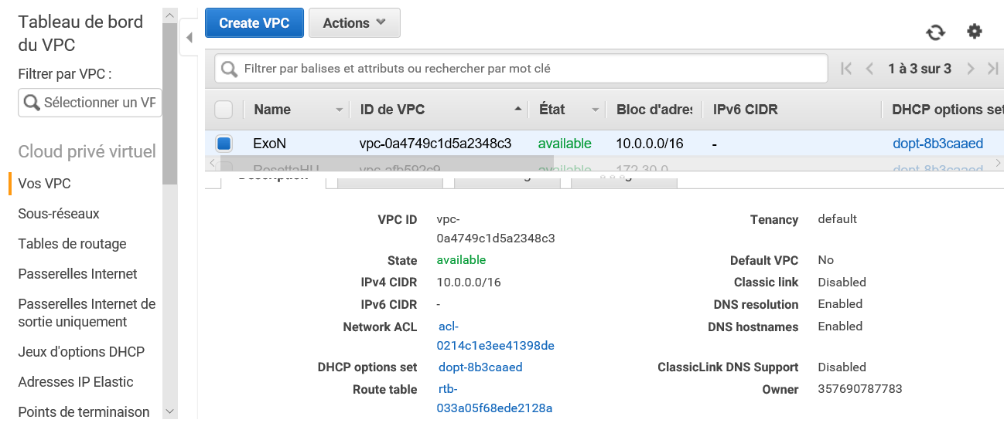

Create a public subnet

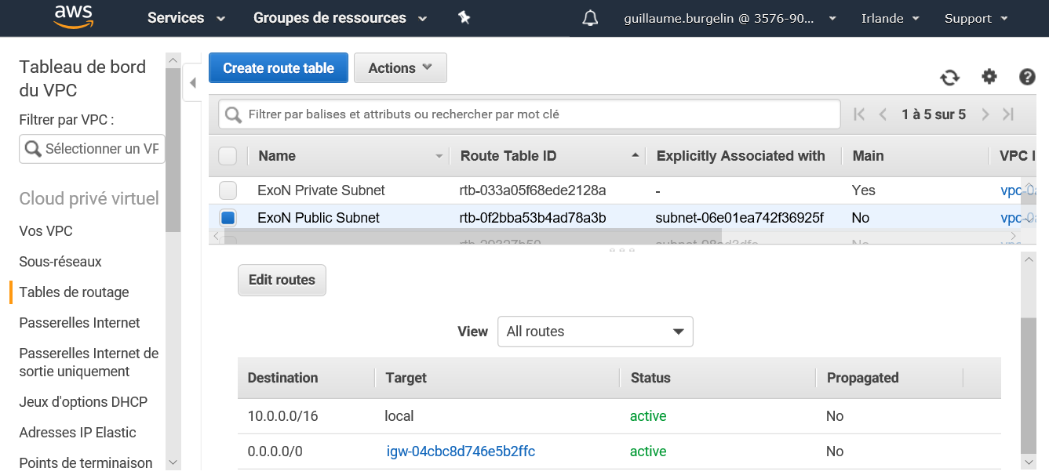

Create a private subnet

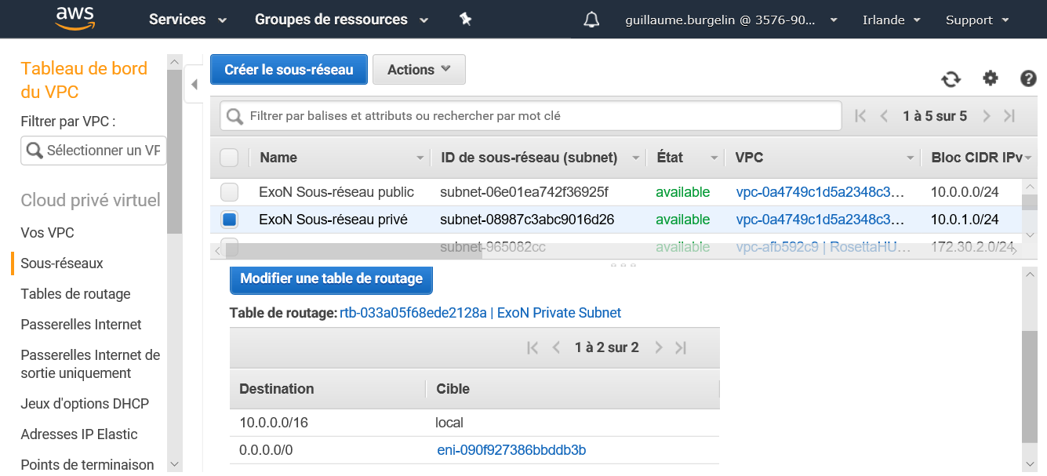

Create a security group allowing HTTP, SSH and ICMP for the Public Subnet instances

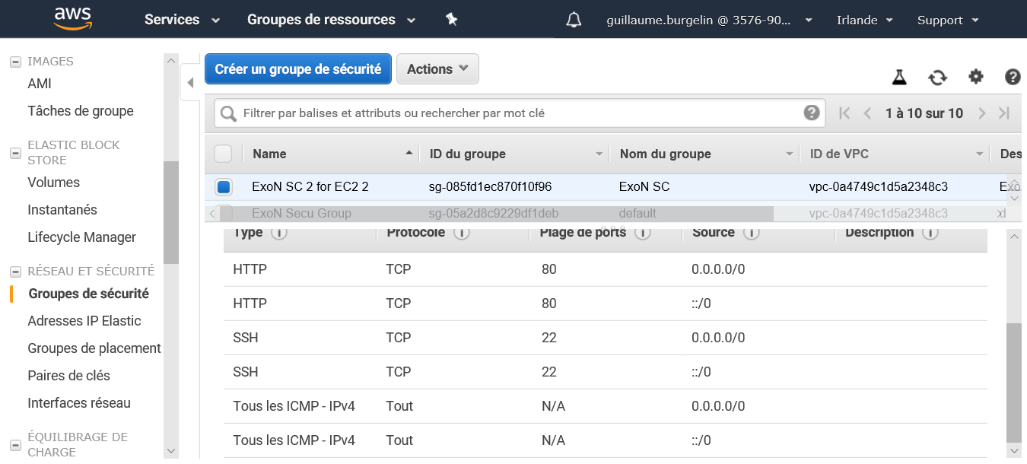

Create 1 instance in the private subnet and 2 instances in the public subnet

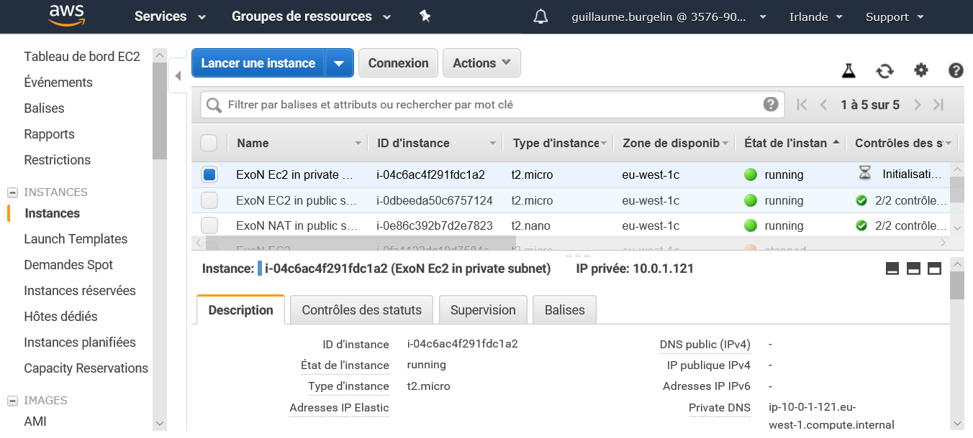

Public IP NAT : [63.33.75.25](https://eu-west-1.console.aws.amazon.com/ec2/v2/home?region=eu-west-1#Addresses:search=63.33.75.25;sort=publicIp)

Public IP Contact EC2 : 18.202.226.42

Connection EC2 Contact

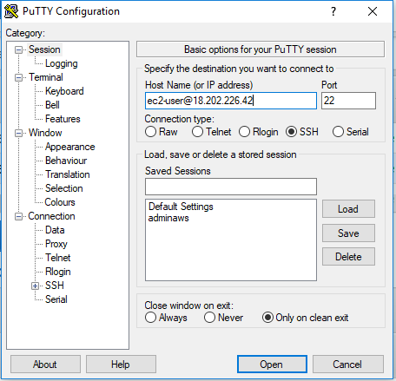

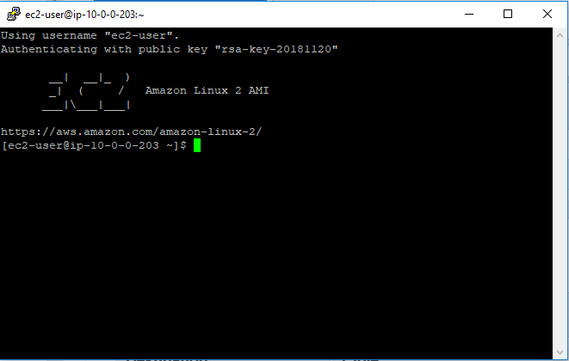

Ping the EC2 in the private subnet with the private IP  
Use the ssh command to connect the EC2 in the private subnet and ping google.com

